|  |
| --- |
| **Project Title : Online Campus Selection System** |
| **Project Concept :** The system developed for job seeker and recruiter, The system provide intermediate place for job seeker and company. . |
| **Type of Project :** Web Application |
| **Technology :** ASP.Net C# Language as Front End |
| **Database :** SQL-Server as Back End Database Server |

**Online Campus Selection System**

What is Campus Selection System?

The Online Campus Selection System developed for HR Department with including automate the functioning of HR Department. This system is helpful for HR Department to make easy student selection process. We  can say this system similar to Human Resource Management System.

The online campus selection software work at college or university. The College invited to recruiter/company for register in this system and help to get employee easily as per their qualification and requirements. Other hand college has all the student data submitted in this system so student can get easily job. The system is a mutual place for student and company. The online campus selection system helps student to get job and company to get employee.

### PURPOSE  of Campus Selection System

**GOAL :**

Maintain individual Student record.  
Maintain Section wise Student details.  
Evaluating Student performance.  
Generating random ID for each student which is unique.  
Making only eligible Students to take the test.  
Allow online registrations for the On-Line Selection Test.  
Allow online requests and support for the examination.  
Providing proper Technical Assistance to the User.  
Providing On-Line Help

**OBJECTIVE :**

Development of rich web based Campus Selection System for Universities and any Companies. Online Campus Selection System is developed for smooth working of Human Resource Departments. Universities and companies can get benefited through this system. This Software is fully integrated with Student and Company Relationship Management and developed in a manner that is easily manageable, time and cost saving that shows relieving one from manual works. Online Campus Selection provides automated technical screening, intellectual evaluation, electronic mail integration to conduct recruitment. This feature’s helps in many ways like saving cost, time and paper work, this shows the paperless environment, unlimited Custom and reports.

**SCOPE :**

This system automates the Selection process activities that the HR Department has to perform prior to and after the actual act of selecting the students. This system helps in various ways such as saving time and cost of selecting Students and companies. That set of concepts is used to build a system for easily Communication between students and companies and company can get required eligible students.

Database Design for Campus Selection System :

**1. AdminMst : Table used to keep admin login information.**

[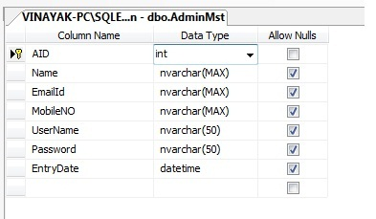](https://meeraacademy.com/asp-net-project/online-campus-selection-system-in-asp-net-c-project/attachment/adminmst/)Campus Selection System Database

**2. StudentMst : Table used to store student detail with personal and address detail in project.**

[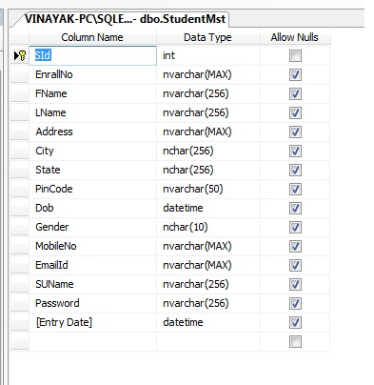](https://meeraacademy.com/asp-net-project/online-campus-selection-system-in-asp-net-c-project/attachment/stumst/)Campus Selection System Database

**3. EducatonMst : Education Master table used to store education detail  of  all the registered students in system.**

[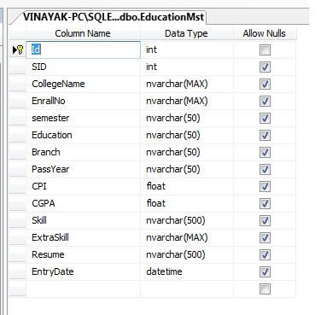](https://meeraacademy.com/asp-net-project/online-campus-selection-system-in-asp-net-c-project/attachment/educationmst/)Campus Selection System Database

**4. CompanyMst : Company master table store company  personal detail.**

[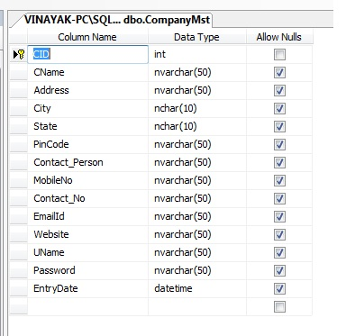](https://meeraacademy.com/asp-net-project/online-campus-selection-system-in-asp-net-c-project/attachment/compaymst/)Campus Selection System Database

**5. AddJobMst : Company adds job detail as per their requirement.**

[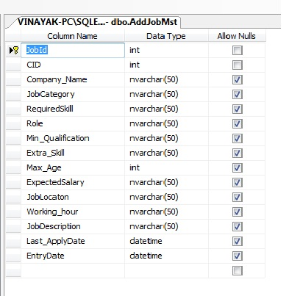](https://meeraacademy.com/asp-net-project/online-campus-selection-system-in-asp-net-c-project/attachment/addjobmst/)Campus Selection System Database

**6. ApplyJobMst : This table store information about which student apply in which company job.**

[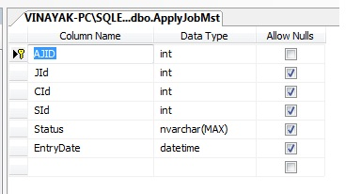](https://meeraacademy.com/asp-net-project/online-campus-selection-system-in-asp-net-c-project/attachment/applyjobmst/)Campus Selection System Database

**7. AdminInboxMst : Store messages for admin only.**

[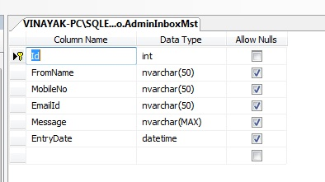](https://meeraacademy.com/asp-net-project/online-campus-selection-system-in-asp-net-c-project/attachment/admininboxmst/)Campus Selection System Database

**8. InboxMst : Table used to  store messages for student and company.**

[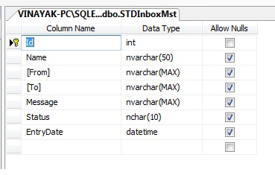](https://meeraacademy.com/asp-net-project/online-campus-selection-system-in-asp-net-c-project/attachment/inboxmst/)Campus Selection System Database

**9. EligibleMst : Store only those student data who are eligible for exam test.**

[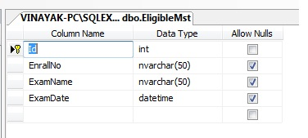](https://meeraacademy.com/asp-net-project/online-campus-selection-system-in-asp-net-c-project/attachment/eligiblemst/)Campus Selection System Database

**10. QPaperMst : This sql table keeps records of question paper detail.**

[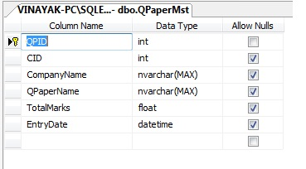](https://meeraacademy.com/asp-net-project/online-campus-selection-system-in-asp-net-c-project/attachment/questpapermst/)Campus Selection System Database

**11. QuestionMSt : This sql table keeps records of questions by question paper wise.**

[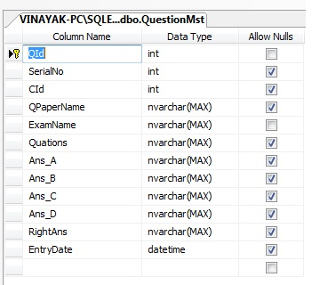](https://meeraacademy.com/asp-net-project/online-campus-selection-system-in-asp-net-c-project/attachment/questionmst/)Campus Selection System Database

**12. ResultMst : The Result master table used to stores the result of students.**

[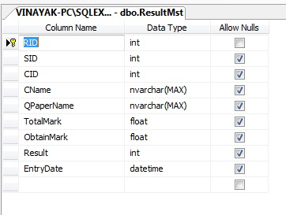](https://meeraacademy.com/asp-net-project/online-campus-selection-system-in-asp-net-c-project/attachment/resutlmst/)Campus Selection System Database